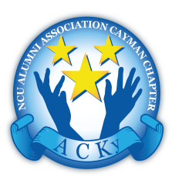
The Cayman Chapter
The Northern Caribbean University Alumni Association
C/o P.O. Box 515, 209 Walkers Road
Grand Cayman, KY1-1202
September 15, 2020

Please return form: Good Samaritan Pantry, c/o shirlenehenriques@gmail.com, 325-9917

NEEDS ASSESSMENT FORM

Date
Disability
NAME | FIRST | Initial | Surname
Address
POSTAL CODE |  | PHONE
EMERGENCY NAME & CONTACT #
DOB
EMAIL

SOCIAL STATUS | SINGLE | MARRIED
 | SINGLE PARENT | WIDOWED / SEPARATED
 | DIVORCED | COMMON LAW

PEOPLE LIVING UNDER THE SAME ROOF
SURNAME | FIRST NAME | DOB | RELATIONSHIP TO RECIPIENT

